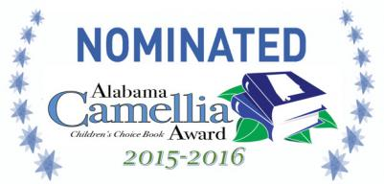Rules and Description

General Description

1. The purpose of the Alabama Camellia Children’s Choice Book Award is:
- To encourage Alabama young readers to become better acquainted with recently published quality books.
- To honor favorite books and authors.
- To encourage Alabama young readers to engage with and build their own story by drawing on the lessons found within quality literature.

2. The award is given annually in the following grade divisions:
- K-1
- 2-3
- 4-5
- 6-8 (A separate fiction division AND a separate non-fiction division)

3. The winning book in each division is determined by the total vote of young
reader’s in Alabama. Voting is open to public and private K-12 schools as well
as patrons of public libraries.

4. The awards are announced on the first Friday of April.

5. The Camellia Children’s Choice Award is sponsored by the Alabama State
Department of Education Library Media program.

Nomination Requirements

Titles are submitted for nomination by publishers and are narrowed to 10 in each division by selected school based professionals for each level.
- Titles are submitted for consideration by national publishers.
- Alabama School Library Media professionals choose ten books per level.
- The selected books are announced for statewide consideration.

Voting Requirements

- The school library media specialist (LMS) will register their school for
participation by visiting the ALMO site and signing up.

- To become qualified voters, young readers must be exposed to all of the
nominated books in their appropriate division by:
i) Reading the books themselves.
ii) Having the books read to them.
iii) Any combination of the two.

- Qualified voters are allowed one vote per grade level division. Remember, if
students vote in more than one grade level division, all books from the additional division must also be read.

- A responsible adult in a classroom or library setting must monitor the voting
procedure, and then only one tally should be submitted for each participating classroom or library to the school library media specialist who will submit the schools total votes. Upon school registration, a link to the voting site will be supplied to the Library Media Specialist.

- Vote totals are due at the State Department. (Date to be announced)

